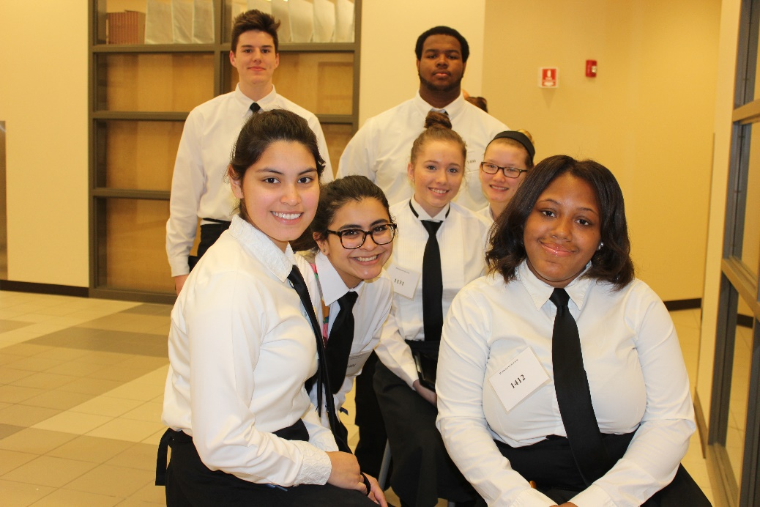
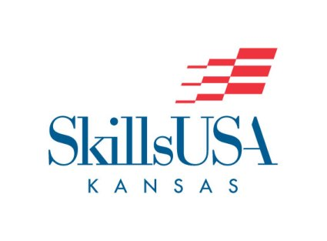
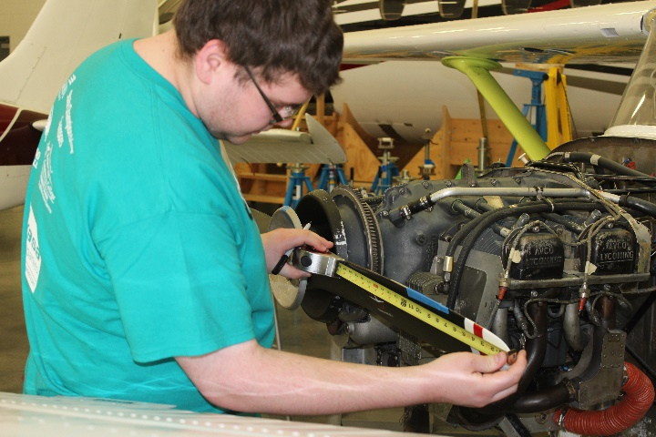
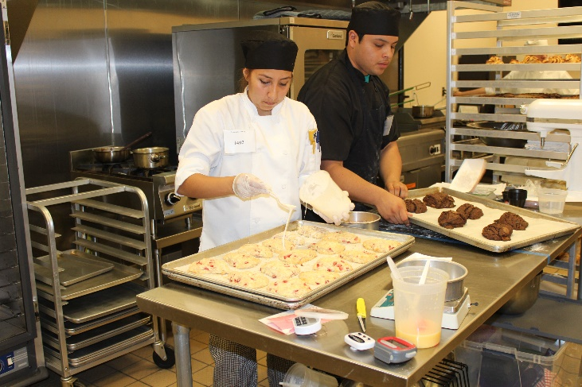
FOUNDED 1965

Over fifty years ago, 200 students, teachers and administrators held a conference at the hotel in Nashville, Tenn. In founding the Vocational Industrial Clubs of America (VICA), their goal was to establish a nationwide organization to represent trade and industrial education and to serve student needs.

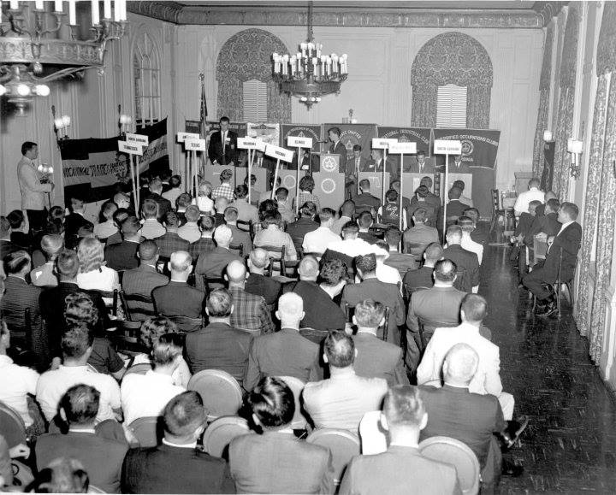
Now, SkillsUSA changes lives every day. Students discover and grow their career passions and appreciate their own self-worth through the work and dedication of instructors, administrators, association directors, industry partners and alumni.

SkillsUSA continues to reach toward the founders’ vision, but, bottom line, our core purpose is the same: to help instructors reach and engage their students so their student will succeed.

SkillsUSA is privileged to serve students, schools, colleges, and industry, and the most inspiring instructors and administrators in American education.

As a national organization, SkillsUSA has grown from 26 State and territorial associations to 54 and served over 14 million members since 1965. More than 600 businesses, corporations, trade associations and labor unions are partners at the national level alone, with thousands more supporting at State and local levels.
SkillsUSA has employability and leadership training with award-winning curricula, such as the Professional Development Program, that supports SkillsUSA’s Program of Work. Our training, conducted in more than 17,000 classroom sections, provides applied instruction and opportunities for Career Technical Education (CTE) students to lead as officers and serve as chapter members.

SkillsUSA has civically engaged chapters that conduct thousands of community service activities every year, using their occupational and leadership skills to benefit their neighbors, hometowns and the nation. CTE students gain public respect and understanding as a result. As important, they experience the exhilaration of helping others as they become Champions at Work.

SkillsUSA supports the skilled workforce. SkillsUSA is addressing both the skills gap and skilled worker shortages through programs such as the SkillsUSA Championships and industry-driven Skill Connect Assessments. We serve 130 occupational titles that represent one-quarter of the jobs offered by our economy. Our work is very much about America’s future.

SkillsUSA represents CTE from local school boards to governors and statehouses and all the way to Washington D.C., SkillsUSA continues to send a long line of red blazers to talk with policymakers, legislators, and the news media about the purpose of career education and how important it is to students and employers. Our students are the “face” of CTE.

SkillsUSA Kansas foundation created in 1966 to provide support for career technical education and SkillsUSA Kansas. The Foundation is SkillsUSA’s philanthropic arm. The foundation is comprised of representatives from business, industry, organized labor and other interested parties.

The SkillsUSA Kansas Foundation provides support to the goals and purposes of SkillsUSA, including student awards, preparation of special publications or funds for the SkillsUSA Kansas Championships. A committee of key business leaders from corporate America assists in fundraising and offers expert advice and counsel. The SkillsUSA Kansas Youth Development Foundation focuses to help raise approximately 25 percent of SkillsUSA Kansas’s overall operating budget each year ($75,000). In addition to this operating support, funds raised support SkillsUSA’s mission related programs and events, including the National Leadership and Skills Conference.

Building Business Industry Partnerships is the heartbeat of our organization. SkillsUSA Kansas recognize our partners and exposes them to our members while developing members’ leadership and career skills necessary to be successful in the workplace. Our partners provide a return on investment in our members.

Benefits of Partnership: SkillsUSA is focused on filling the Skills gap and career readiness in America. Ensuring that programs meet industry needs, providing opportunities for employment, and helping to promote specific industries in offering a way to support local career technical education programs.
SkillsUSA Kansas partnership supports six different levels:

Level 1: BRONZE Level 4: PLATINUM
Level 2: SILVER Level 5: DIAMOND
Level 3: GOLD Level 6: PREMIUM DIAMOND

SkillsUSA Kansas is a non-profit 501 3(c) organization. All donations are tax deductible and donors will receive a receipt for all contributions made to the organization.

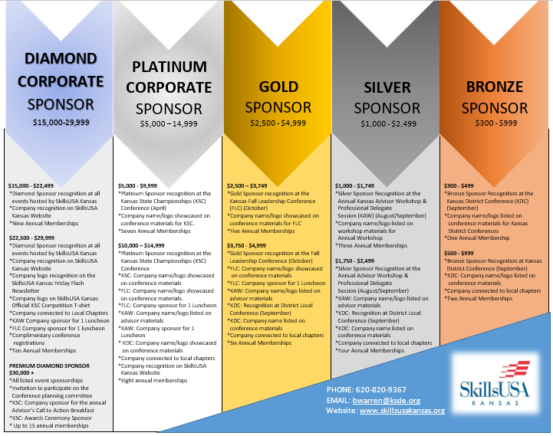

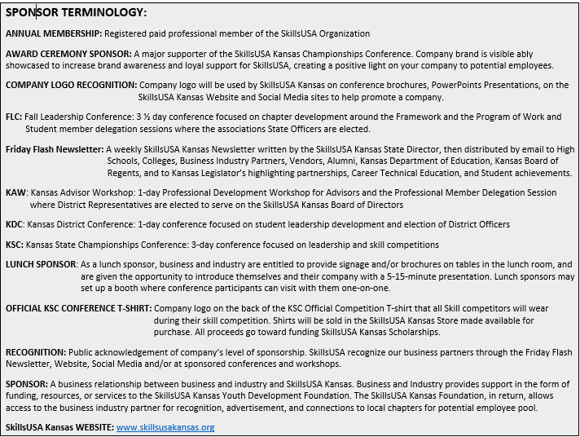

Corporate Partnership Agreement

SkillsUSA Kansas partners are supporters of career technical education. Our partners have an opportunity for input into skill training, a chance to recruit top technical students and the opportunity to help develop America’s future workforce.

SkillsUSA Kansas serves more than 3,400 career and technical students and teacher. These students are training in our top schools and college/postsecondary institutions in a variety of careers such as cosmetology, automotive technology, aviation technology, machining, drafting, engineering, culinary arts, computer technology, electronics and more.

More than 1,200 companies and organizations across the nation participate in SkillsUSA programs. Companies benefit by having input into specific skill training, an opportunity to recruiting top technical students, and the good feeling that comes from helping America’s future workforce develop marketable skills. Many industries today face a shortage of skilled workers, and SkillsUSA offers a tangible way to help solve this problem by ensuring that there will be a future workforce trained in the skills industry needs.

To become a partner with SkillsUSA Kansas, complete the form and return it to the Kansas State Director. The director will contact you to go over the details of the partnership, making sure your company is satisfied with the agreement prior to the annual sponsorship deadline of September 1st.

FIRST NAME: LAST NAME:

TITLE:

COMPANY:

COMPANY ADDRESS:

CITY: STATE: KS ZIP CODE:

COMPANY PHONE NUMBER:

EMAIL:

COMPANY WEBSITE:

SPONSORSHIP LEVEL: AMOUNT OF DONATION: $

SEND COMPANY LOGO AND CORPORATE PARTNERSHIP AGREEMENT FORM TO bwarren@ksde.org

NOTE: ANNUAL SPONSORSHIP TIMELINE IS ACADEMIC CALENDAR: SEPTEMBER 1 through AUGUST 31

Thank you for supporting the students of Kansas!

