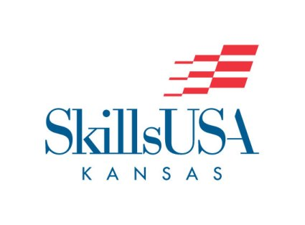
This application is for instructors who desire to serve on the SkillsUSA Kansas Board of Directors.

Qualifications:
- Professional Paid Member for 3 years or more.
- Must be active paid member in local chapter of good standing (At least 7 members and 1 professional member and no outstanding invoices to the State Office.)
- Must be willing to serve and support the SkillsUSA Kansas mission and vision of the organization

Required if elected: Elected board members are expected to attend the following meetings:
September: Advisor Workshop
November: Fall Board of Directors Meeting
March: Spring Board of Directors Meeting
April: All board members are expected to support and assist with the State Conference
July/August: Summer Board of Directors Meeting

Required if elected: To serve in supporting all SkillsUSA Kansas annual events
September: District meeting in region
October: Fall Leadership Conference
February: District Kansas Championship Conference
March: Contest Chair Luncheon
April: Kansas State Championship Conference
June: National Leadership Skills Conference (If your school is participating)

If any elected board member misses 3 meetings throughout a year, their position will become annulled.

Applicants Name:

Name of High School/College:

*SkillsUSA Kansas District #

Applicant’s occupational title:

Number of years at current High School/College:

Professional Paid Member for how many years:

How many student members in local chapter:

How many professional members in local chapter:

Describe the local chapters “Program of Work”:

Local chapter in good standing with State: YES NO

If no, why:

To help understand a little about the applicant, please describe your position and the support you actively engage in with the SkillsUSA Kansas organization:

Describe your position and support in the local chapter:

Describe your position and support at the District level:

Describe your position and support at the State level:

Describe your position and support at the National level:

Describe why you are running for a position on the Kansas Foundation Board of Directors:

Signature of Applicant: _______________________________

Signature of High School/College Administrator: ______________________________________

Submit Completed Application to: bwarren@ksde.org by March 1.

The SkillsUSA Director and the Kansas Foundation Board of Directors will:
- Review and verify applicant qualify to serve as SkillsUSA Kansas Board of Director.
- Complete district candidate applications will be presented to the Kansas Professional Membership Delegation for election. Candidates will be expected to give a 5-minute presentation/speech at the Annual Advisor Workshop where elections are held.

*SkillsUSA Kansas Districts
District #1: Northwest (NW)
District #2: North Central (NC)
District #3: Northeast (NE)
District #4: Wichita (W)
District #5: Southwest (SW)
District #6: South Central (SC)
District #7: Southeast (SE)

