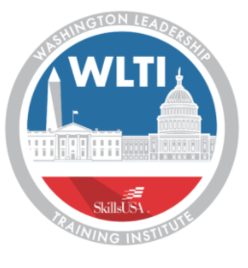
SkillsUSA

Washington Leadership Training Institute (WLTI)

SkillsUSA offers advanced training for students and advisors that focuses on professionalism, communication and leadership skills. This training is held in Washington D.C., and allows members the opportunity to share their SkillsUSA and career and technical education experiences with elected officials.

WLTI activities will include:
- Congressional visits
- Tours of Washington D.C., including monuments
- Laying of a wreath at the Tomb of the Unknowns

Members of SkillsUSA may apply for this great opportunity and experience.

- NAME:

- GRADE LEVEL:

SCHOOL/COLLEGE:
SCHOOL/COLLEGE ADDRESS:

CITY: STATE: ZIP CODE:

SCHOOL/COLLEGE PHONE:

- HOME ADDRESS:

CITY: STATE: ZIP CODE:

HOME PHONE:

EMAIL ADDRESS:

If under 18, NAME OF PARENTS or GUAREDIAN:

- CAREER INTEREST:

- WORK EXPERIENCE (Paid/unpaid):

- SkillsUSA EXPERIENCES: (Check all that apply and describe.):

Committee Work:

Community Service:

Held a local office:

Held a state office:

Contestant at local level:

Contestant at district, regional, or state level:

- Achievements (academic, sports, community, other…):

- Organizations you are involved in other than SkillsUSA:

- Most memorable learning experience:

- What do you hope to gain by attending WLTI?

In the space provided, write a summary outlining personal experiences that have helped you develop your leadership potential. Your summary should be typed and is not to exceed 500 words. Consider the following questions as you write your leadership summary.
- What personal experiences have helped develop your leadership skills?
- How do you know, you have developed as a leader?
- What is your leadership style?
- Who are national leaders you admire?

Your Leadership Summary:

SUBMIT APPLICATION TO: bwarren@ksde.org by March 1st.

